Vdq – i whether storage node or compute node we can know that

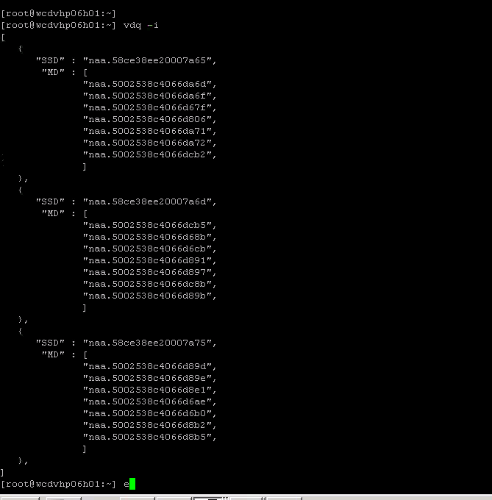

Vsan resync data visibility

Connect to vcenter through shell

root@vapwcvcenter01 [ ~ ]# rvc localhost

1 localhost/

> cd 1

/localhost> ls

0 WC (datacenter)

/localhost> cd 0

/localhost/WC> ls

0 storage/

1 computers [host]/

2 networks [network]/

3 datastores [datastore]/

4 vms [vm]/

/localhost/WC> cd 1

/localhost/WC/computers> ls

0 WC_PROD (cluster): cpu 1480 GHz, memory 9415 GB

/localhost/WC/computers> cd 0

/localhost/WC/computers/WC_PROD> ls

0 hosts/

1 resourcePool [Resources]: cpu 1480.69/1480.69/normal, mem 9415.32/9415.32/normal

/localhost/WC/computers/WC_PROD> cd 0

/localhost/WC/computers/WC_PROD/hosts> ls

/localhost/WC/computers/WC_PROD> vsan.resync_dashboard .

******************************

[root@wcdvhp07h08:~] esxcfg-scsidevs –A (list the all disks)

vmhba3 naa.58ce38ee201851dd

vmhba3 naa.5002538c408c9f40

vmhba3 naa.5002538c408c9f43

vmhba3 naa.5002538c408c9ea7

vmhba3 naa.5002538c408ca1db

vmhba3 naa.5002538c408c9eaf

vmhba3 naa.5002538c408c9f4f

vmhba3 naa.5002538c408ca008

vmhba3 naa.5002538c408c9eb2

vmhba3 naa.5002538c408c9eb5

vmhba3 naa.5002538c408c9eb6

vmhba3 naa.5002538c408c9eb7

vmhba3 naa.5002538c408c9f56

vmhba3 naa.5002538c408c9eb8

vmhba3 naa.5002538c408c9f5b

vmhba3 naa.5002538c408ca010

vmhba3 naa.5002538c408c9e46

vmhba3 naa.5002538c408c9f24

vmhba3 naa.570695a48cad01bd

vmhba3 mpx.vmhba3:C0:T1:L0

vmhba3 naa.5002538c408ca1c4

vmhba3 naa.5002538c408c9f31

vmhba3 naa.5002538c408c9f3d

vmhba3 naa.5002538c408c9f3e

vmhba3 naa.58ce38ee201717e1

vmhba3 naa.58ce38ee20185271

vmhba32 eui.00a0504658335330

Esxcli storage core adaptor list

Esxcfg- module list

P06H01 got POSD due to CPU panic caused by Healthy

Check Congession on the disk groups of a Host :



Run these two commands on all hosts of the cluster to remove the warnings/ errors ,at a later date

esxcfg-advcfg -s 98 /VSAN/ClomRebalanceThresholdvsish -e set vmkModules/vsan/dom/MaxNumResyncCopyInFlight 50

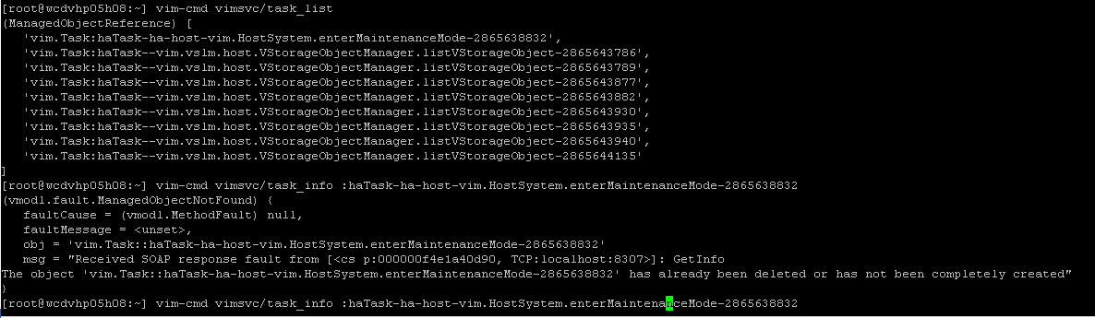







Record the cache and capacity disk ids in the existing group by running this command:  
esxcli vsan storage list

Example output of a capacity tier device:  
naa.123456XXXXXXXXXXX:  
Device: naa.123456XXXXXXXXXXX  
Display Name: naa.123456XXXXXXXXXXX  
Is SSD: true  
VSAN UUID: 52164f1b-668b-ec68-b293-919b04e78fa3  
VSAN Disk Group UUID: 52ab175f-17c6-6f42-e10a-ca86fc1d008e  
VSAN Disk Group Name: naa.50000XXXXX1245  
Used by this host: true  
In CMMDS: true  
On-disk format version: 5  
Deduplication: true  
Compression: true  
Checksum: 5356031598619392290  
Checksum OK: true  
Is Capacity Tier: true  
Encryption: false  
DiskKeyLoaded: false   
  
**Note**: For a cache disk:

* the VSAN UUID and VSAN Disk Group UUID fields will match
* Output will report: Is Capacity Tier: false